# Guidelines for using the ALC-TM4 and BioPatRec

This guideline provides information on how to assemble the board, how to connect it to the PC and finally how to use it though MATLAB program BioPatRec for online and offline analysis.

## Assembling the board

### Connecting electrodes, Bluetooth and power

#### Components

(1.2)

(1.1)

(4) *ALC (bottom side)*

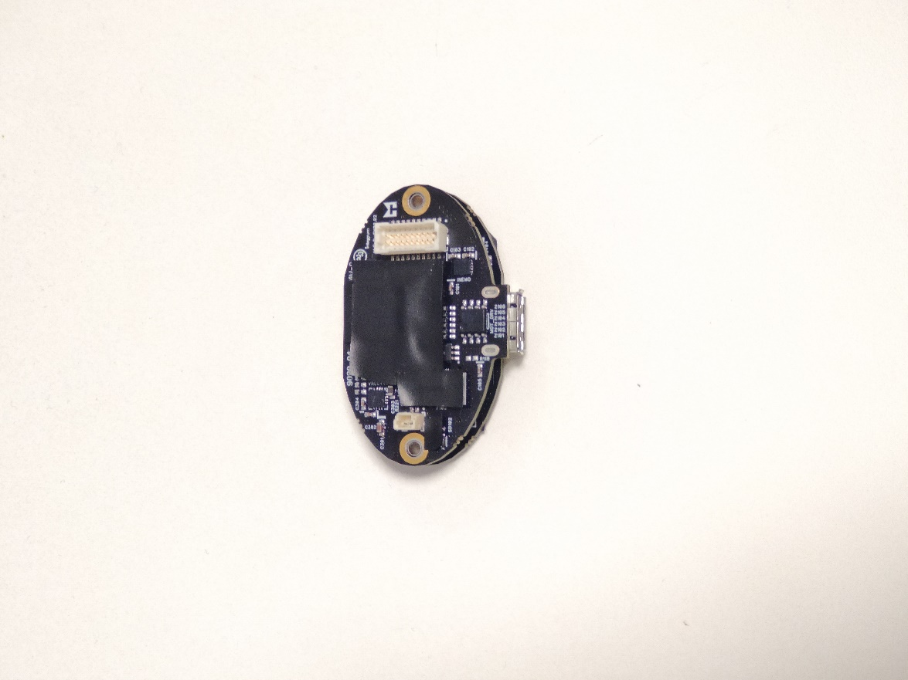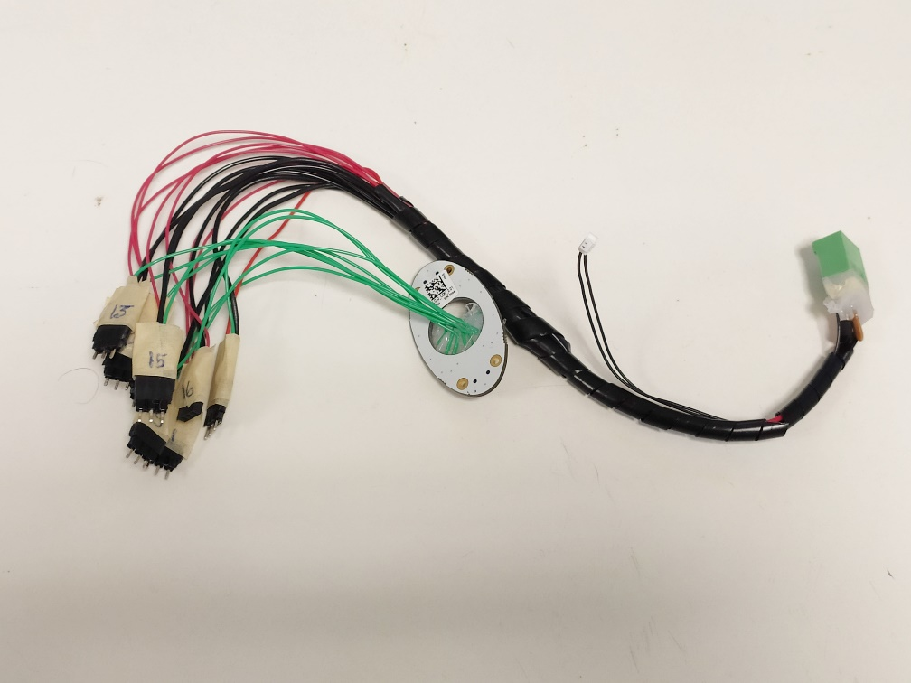

(4.1)

(5.3)

(5.2)

(5.1)

(5) Electrode connector

(3) *Bluetooth dongle (PC side)*

(2) *Bluetooth dongle (ALC side)*

(1) *ALC (top side)*

1. 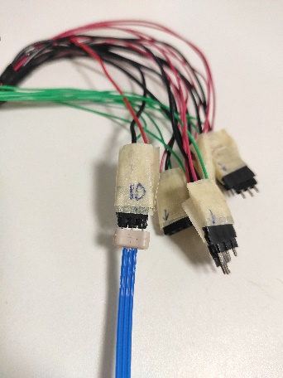Insert the Bluetooth dongle (ALC side) (2) in the ALC (1)
2. Connect the Electrode connector (5), by attaching the (5.1) to the top side of the ALC. On the bottom side of the (5.1) there is an arrow which must correspond to the dot (1.1) on the ALC
3. Connect the (5.2) of the Electrode connector to the power plug on the bottom side of the ALC (4.1)
4. Connect the (5.3) part to the battery or power supply (8V, 4A)
5. Connect the Ottobock electrodes as shown in the picture on the right. The blue part must face the number written on the connector.
6. IMPORTANT: The number of electrode connectors available are: 8, 10, 11, 12, 13, 14, 15 and 16. These correspond to the number of the channel.

* Final result of the assembling is shown below

#### Assembled

#### Final result of the assembling

### Debugging and flashing the code

#### Components

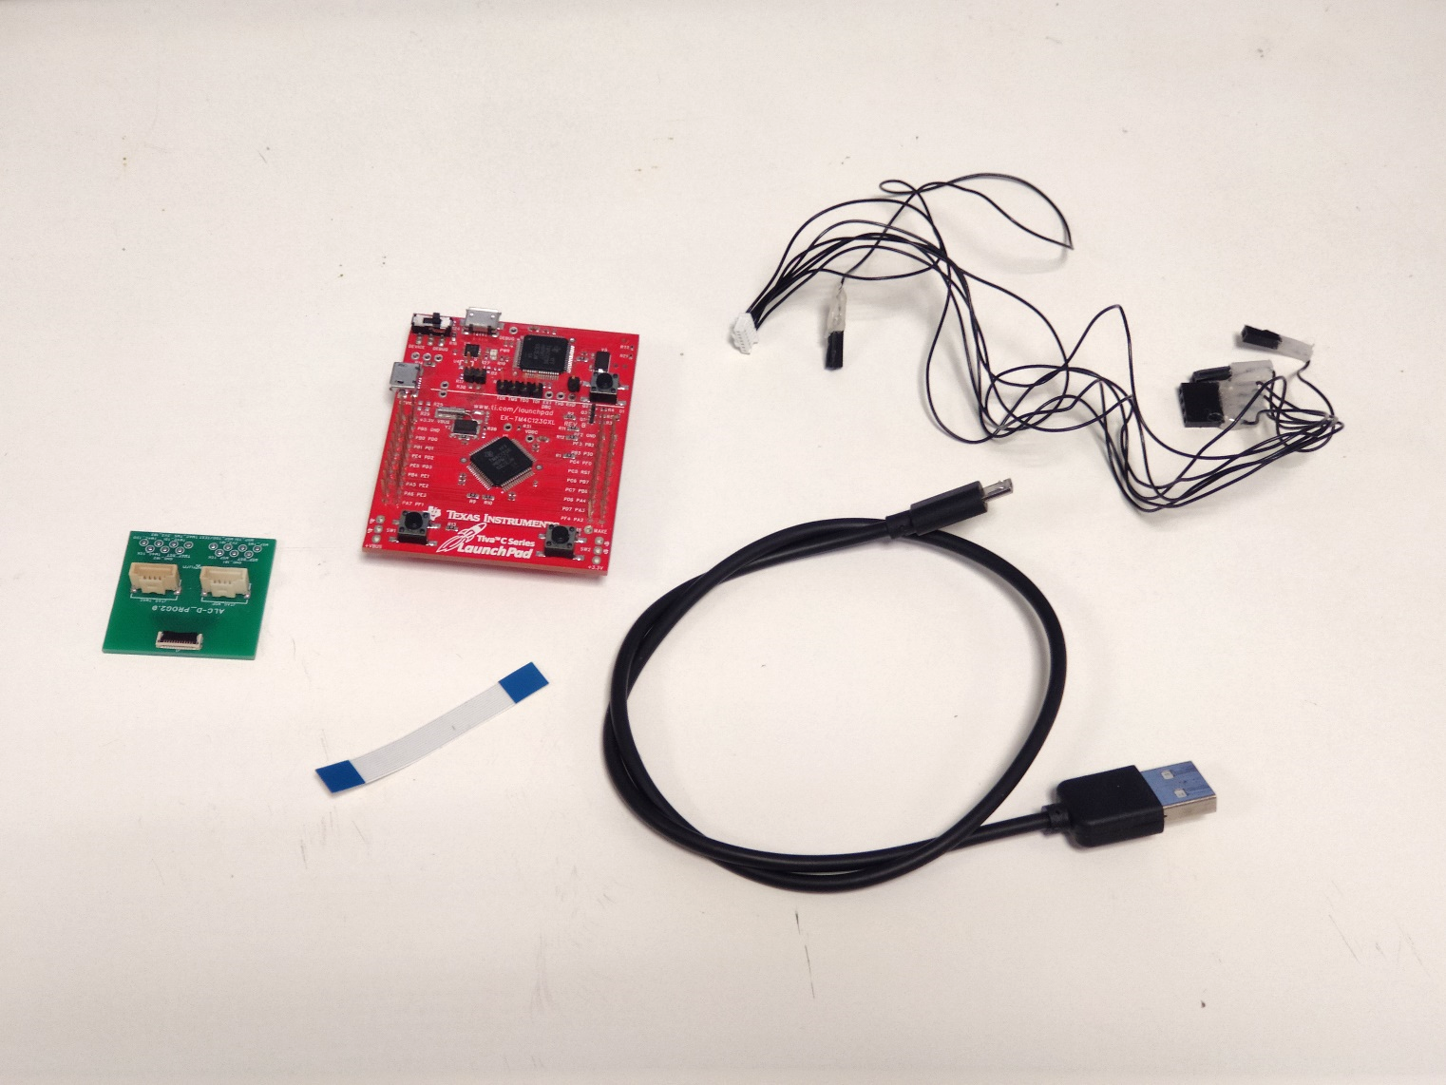

(7.1)

(8.2)

(8.1)

(9) *USB cable*

(8) *Tiva-PROG connector*

(7) *Tiva LaunchPad*

(10) *Strip connector*

(6) *PROG connector*

(6.4)

(6.3)

(6.2)

(6.1)

1. Connect one side of the strip connector (10) to the ALC (1.2) and the other to the PROG connector (6)
2. Connect the Tiva-PROG connector (8.1) to the PROG (6) and (8.2) to the Tiva LaunchPad (7)
   1. The (8.1) goes to JTAG_TM4C (6.1)
   2. (6.2) pin, or second wire from the right of the (8.1) is the TM4C_TCK and needs to be connected to the same pin on the Tiva LaunchPad (7.1) with the (8.2) part (connection with 4 pin)
   3. (6.3) pin is the ground, or the middle wire on the (8.1), should be connected to one of the ground pins on Tiva (7) with its corresponding (8.2) part
   4. (6.4) pin is the reset, or the second from the left on the (8.1), needs to be connected to the reset pin on (7), with its corresponding (8.2) part
3. Connect the USB cable (9) to Tiva LaunchPad (7) and to the PC
4. Make sure that the ALC is powered if you want to flash the code or debug

* Final result of assembling

#### Assembled

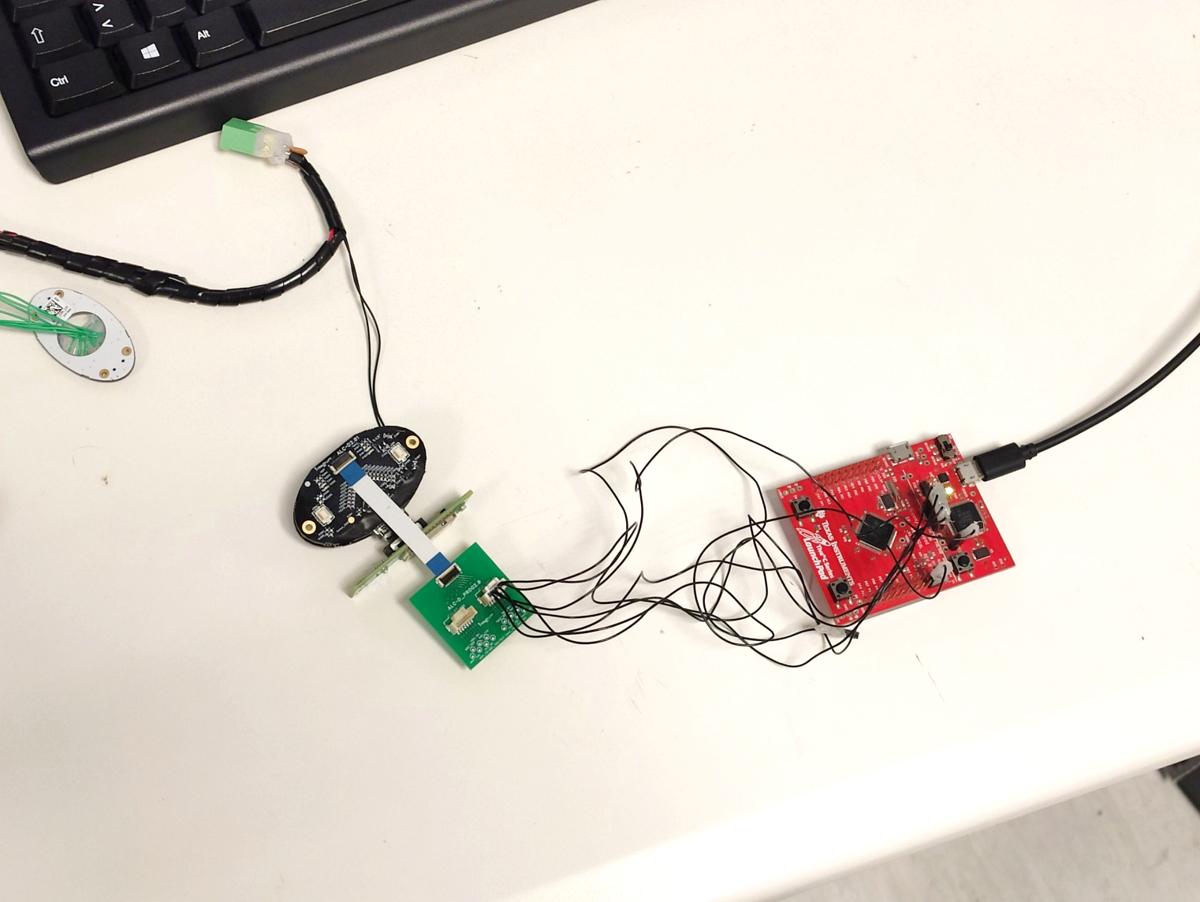

## Using the board

### LED indications

* GREEN LED blinking (at ~2Hz) – as soon as the ALC is turned on the green light should be blinking indicating that the program is running
* GREEN LED blinking (at ~10Hz) – acquisition is happening while in COMMAND mode
* BLUE LED blinking – the Bluetooth device is present but not connected
* BLUE LED constant – the Bluetooth device is connected

### Connecting ALC to the BioPatRec

1. As soon as the device is powered the GREEN LED and BLUE LED should blink.
2. Plug the Bluetooth dongle (PC side) and wait for the BLUE LED to be constant.
3. Open NCALfit in MATLAB, choose the proper COM from menu (2) and press **Connect** (1)
4. Graphical user interface, chart, line chart

   Description automatically generatedTo check the signal of the electrodes, select the electrodes that you will be using from the **Channels** bar (3), enter in the **Sampling** text box (4) the amount of seconds that you want to record and press **Start** button (5).

(5)

(4)

(3)

(2)

(1)

Figure 1 NCALfit

### Using Direct control

#### Record the thresholds

1. From the menu bar in NCALfit, choose **Direct-Control**
2. From the descending menu choose **Direct Control fitting** and the GUI in figure 2 should show up
3. Choose from the popup menu (1) the movement you want to record and the channel it will correspond to (popup menu (2)).
4. When all desired movements are selected, choose the amount of time you want to record the signal (text box (3)) and press **Start Acquisition** button (4)
5. After the acquisition is finished, adjust the **blue thresholds** in the plot box (5) by dragging them to adjust the passing threshold of the corresponding movement
6. Adjust the **red thresholds** in the plot box (5) by dragging them to adjust the value for MVC (maximally voluntary contraction)
7. **COCONTRACTION SWITCH** (6)
   1. In order to enable the switch with cocontraction, select the check box **Enable**
   2. To regulate the cocontraction thresholds, in the text boxes **open hand** and **close hand** input the percentage of the corresponding threshold that will be used as the cocontraction threshold (ex. 1.1 for open hand cocontraction threshold is 110% of the open hand threshold)
   3. In the text box **Wait next coco. Time** input the amount of time the algorithm should wait for cocontraction to happen (1 corresponds to 100ms)
8. Graphical user interface, diagram

   Description automatically generatedTo set all the parameters of direct control press the **WRITE SETTINGS** button

(1)

(2)

(5)

(2)

(1)

(3)

(4)

(6)

(5)

Figure 2 Direct Control

**Note: For Direct Control make sure that only MAV feature is enabled. To check the enabled features (and all of the board status), from NCALfit choose in the menu bar Hardware and then Check status. To change the selected features, go to Hardware, then choose Advance Settings.**

#### Online test

1. From the menu bar in NCALfit, choose **Prosthesis**, and then **Configure & Test**
2. The GUI from the figure 3 should pop up
3. Text box **Run predictions** corresponds to the number of output instances that you will receive
4. Press on **Test** button to start the online prediction

Figure 3 Online test for Direct Control

### Using Pattern Recognition (SVM for EMG transient)

#### Recording the data set

1. Open **BioPatRec** and choose **Recording Session**
2. The GUI on figure 4 should pop up
3. Enter the number of repetitions per movement, enter the contraction time (in seconds) and relaxing time (in seconds)
4. Select the movements you want to record from the list box
5. Check the **Check & Repeat** check box
6. From popup menu (1) choose **ramp**
7. Press **Record** button
8. The GUI on figure 5 should pop up
9. Under **Device name** select **ALC-24chs**
10. Choose the **channels** that you want to use, the **sampling rate** and the **COM** from which you record
11. Press **Record** button
12. Recording session starts by recording the rest state, followed by MVC for each selected movement. Subsequently, the individual movement recording starts. After each movement, there is an option to re-record the movement by entering in the pop-up box “y”.
13. At the end of the recording session, save the file in the desired folder.

(1)

Figure 4 Recording Session

Figure 5 Select the device

#### Offline model training

1. From the **BioPatRec** GUI, choose **Pattern Recognition**
2. The GUI from figure 6 should popup
3. Press the **Get Sig. Features** button and choose the file which contains your data set
4. GUI shown on figure 7 will popup
5. From the list box **Movements**, select the classes that you want to train, and from the list box **Channels** choose the channels that you want to use
6. If you are using transient EMG, make sure that the **Add “rest” as a movement”** check box is checked
7. Press the **Pre-Processing button**, and then the **Treat** button
8. Wait until the GUI disappears

* For training the model for online testing the parameters should be set as in figure 6:
  1. The chosen features should be tmabsTr1,2 and 3
  2. Chosen classifier is SMVt with linear kernel
  3. Check box **Train using all** needs to be checked
  4. **Derivative Onset** check box is first not checked and the **Onset Th. Coef.** should be 0.4
  5. Press **Run Off-line Training** button
  6. After the training is complete, choose the **ALC-D** from the menu bar, and then press **Upload PR-coefficients**
  7. When the upload is complete, change the value in **Proportional Ratio** to the value indicated in the “Figure 2” of MATLAB given by the previous offline training
  8. Check the **Derivative Onset** check box and change the value in **Onset Th. Coef.** text box to 1
  9. Run the offline training by pressing the **Run Off-line Training** button
  10. Again, from the menu bar choose **ALC-D**, and then **Upload PR coefficients**
  11. From the **ALC-D**, choose **Upload PR table:**
      1. Press “okay”, and choose the file of your data set
      2. Press **Use the Maximally Voluntary Contraction session**
      3. Press “Confirm”
  12. The ALC is ready now for online testing
* In case for offline analysis of the data:
  1. Uncheck the **Train using all data** check box
  2. Choose the classifier and topology in which you want to do the analysis
  3. A picture containing graphical user interface

     Description automatically generatedIn case the **Crossvalidation leave-one-fold-out** is chosen, the number of testing samples in one fold is set by changing the value in **Number of repetitions for test** text box

Figure 6 Pattern Recognition

#### Graphical user interface, application Description automatically generatedOnline Testing

Figure 7 Signal Treatment

* Online Test through Pattern Recognition GUI (figure 6)
  1. Press the **Real-time PatRec Mov2Mov** button
  2. A Real-Time Pattern Recognition Mov2Mov will show
  3. Check the **ALC-D** check box
  4. Choose the number of seconds for test by changing the value in **Testing time** text box
  5. Press **Test Real-time PatRec** button to start the online test
* Online Test through NCALfit (figure 1)
  1. From the menu bar choose **Prosthesis**, and then **Configure & Test Mia**
  2. From the **GUI_Prosthetics** enter the number of predictions you want to have and press the button **TEST**